Volume of a Cylinder
Common Core Learning Standard
CCSS.MATH.CONTENT.8.G.C.9
Know the formulas for the volumes of cones, cylinders, and spheres and use them to solve real-world and mathematical problems.

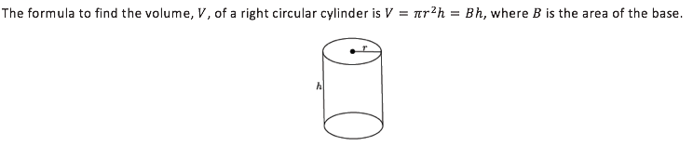
Volume of a cylinder= $π∙r^{2}∙h$

To find volume, we multiply the area of the base by the height of the cylinder

Area of the base = $π∙r^{2}$

Height = $h$

Volume = Area $∙$ Height = $π∙r^{2}∙h$

Example of Volume of a Cylinder:
h= 7 and r= 2
Volume = $π∙r^{2}∙h$
=$π∙2^{2}∙7$
= 28$π$
$≅$87.96
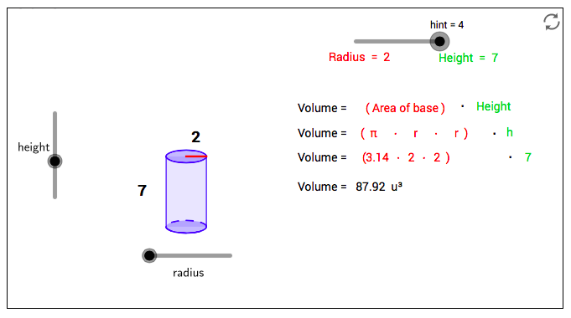
Step 1. Open up GeoGebra
Step 2: Click View -> 3D Graphics | 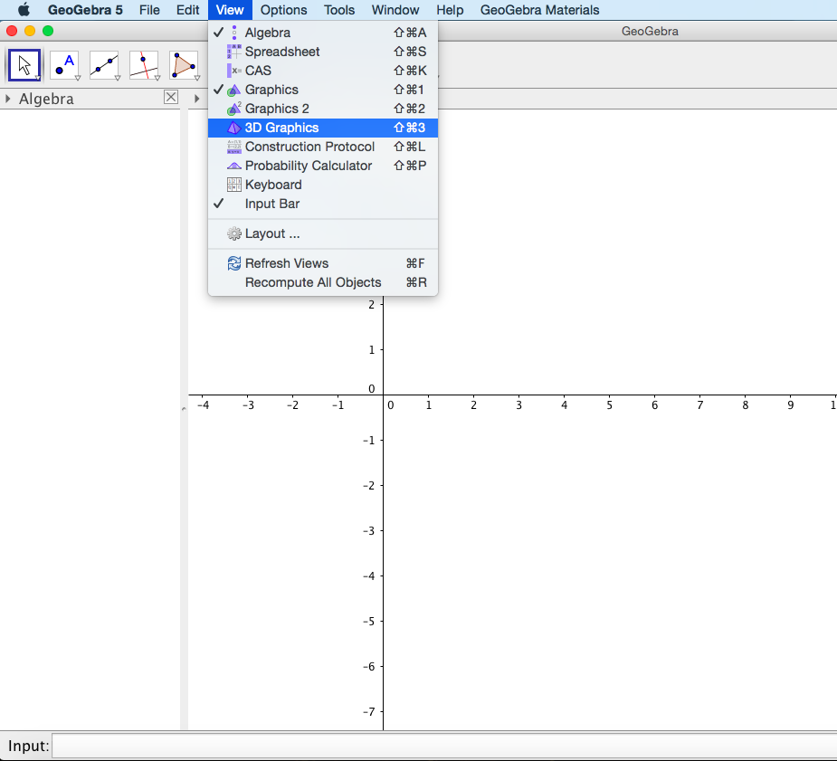
Step 3:  Plot Point A: Click inside the input tab on the bottom of your screen. Type A= (0,0,0) into your input and press ENTER  Plot Point B: Click inside the input tab on the bottom of your screen. Type B= (0,0,5) into your input and press ENTER | 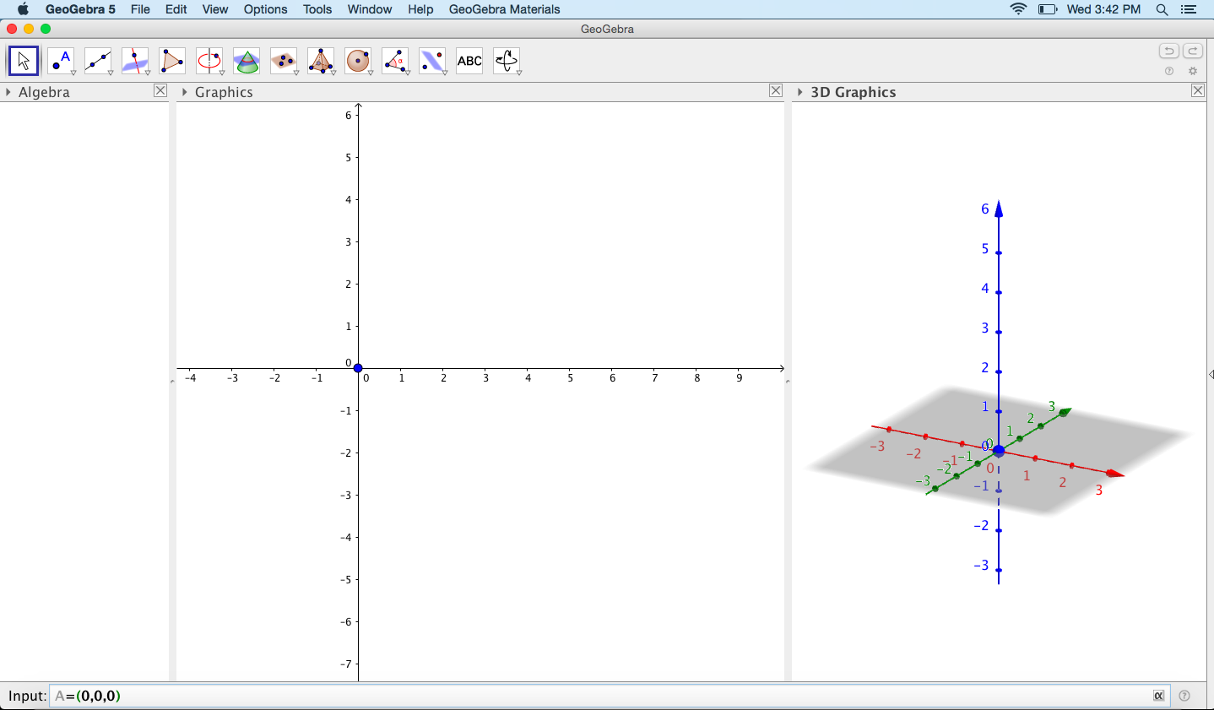
Step 4:  Hide the Axes: First click inside the Graphics graph. Then, click the triangle next to the word Graphics and select the first option on the dropdown menu. (If you keep your mouse hovered over this option it should say Show or hide the axes) | 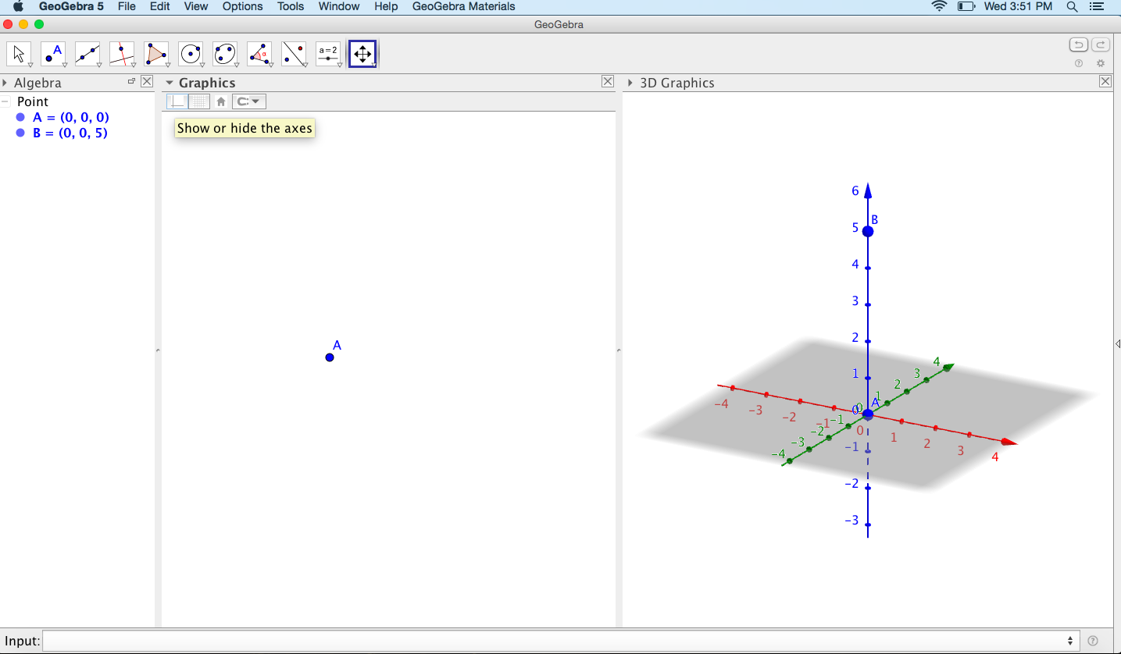
Step 5:  Insert a Slider: On the top menu, select the second to last graphic a=2. (If you hover over this graphic with your mouse it will say Slider.)  After you have selected the Slider option from the top menu, click inside the white space under Graphics. When you do this, a menu will pop up on your screen. In the menu, change the name to r (r is for radius) and change the Min to 0. Then press Ok. | 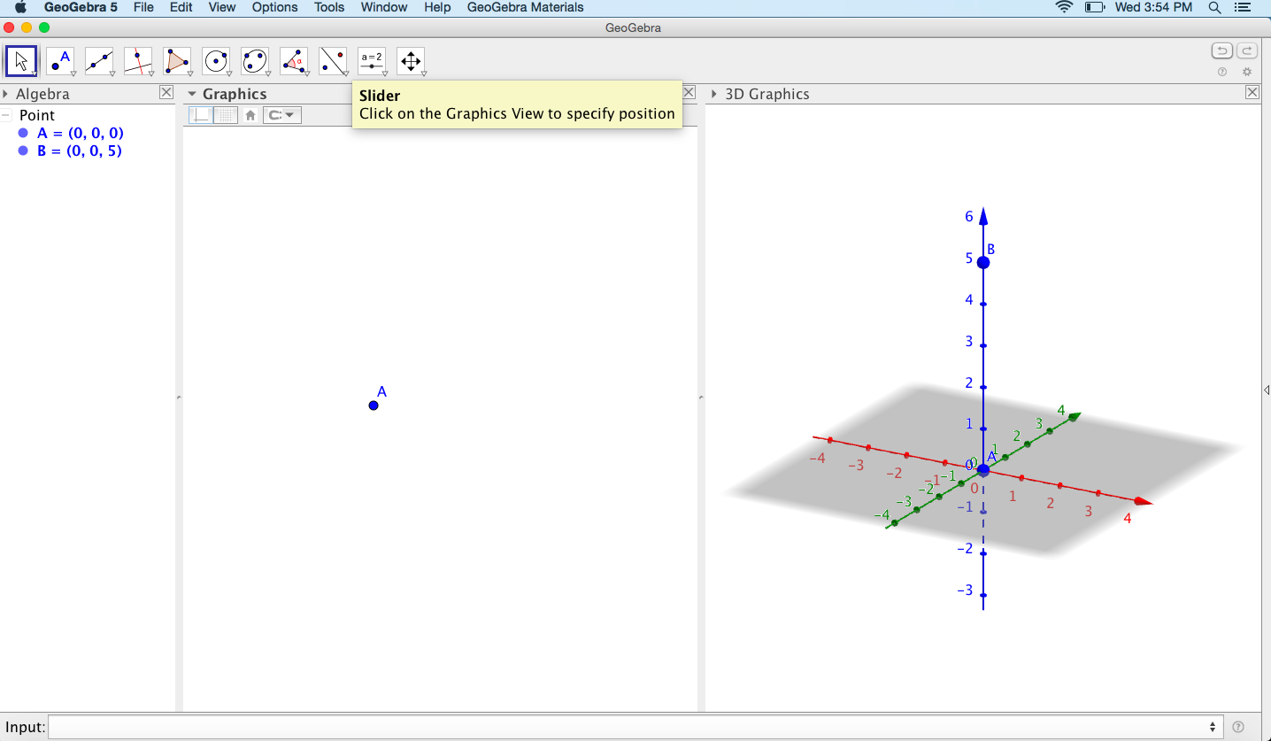  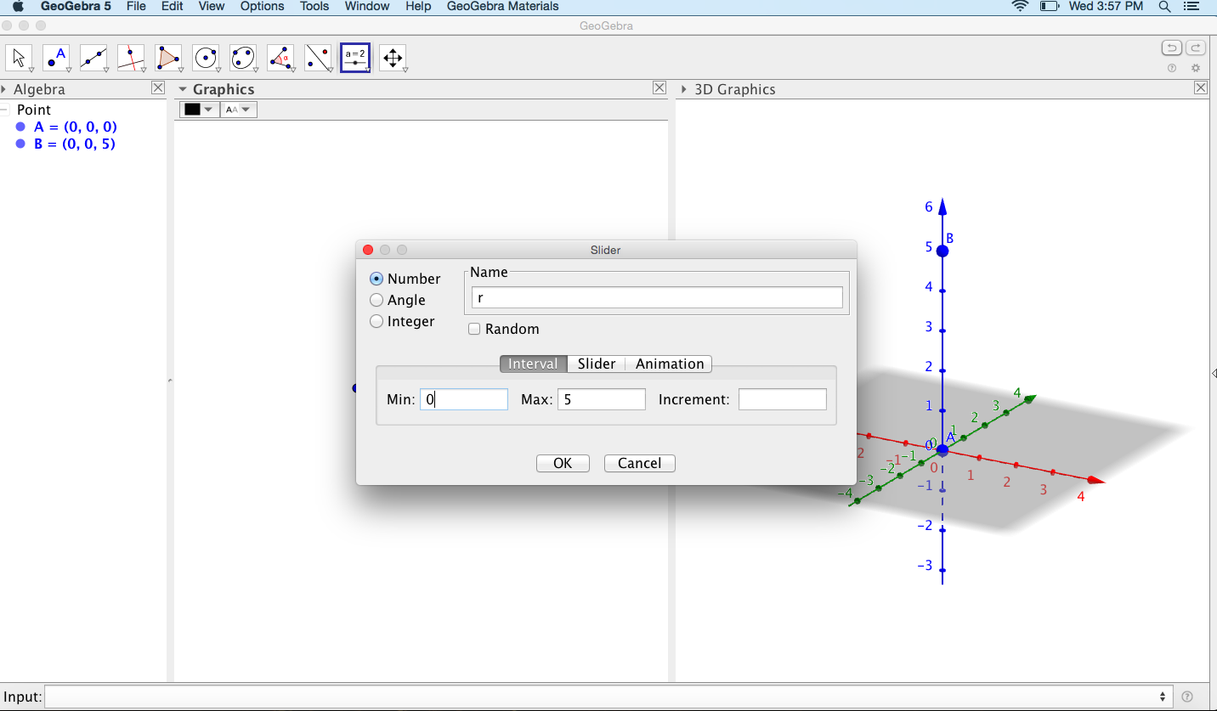
Step 6:  Insert a Cylinder: First click inside your 3D Graphics graph. If a box for a new slider pops up, click cancel. Then, on the top menu, click on the triangle within the ninth graphic that looks like a pyramid. A dropdown menu will appear. Select the option cylinder on the dropdown menu.  In your 3D Graphic click on your point B and then click on your Point A.  A pop-up box will appear on your screen. Inside the pop-up box type in r then press Ok. | 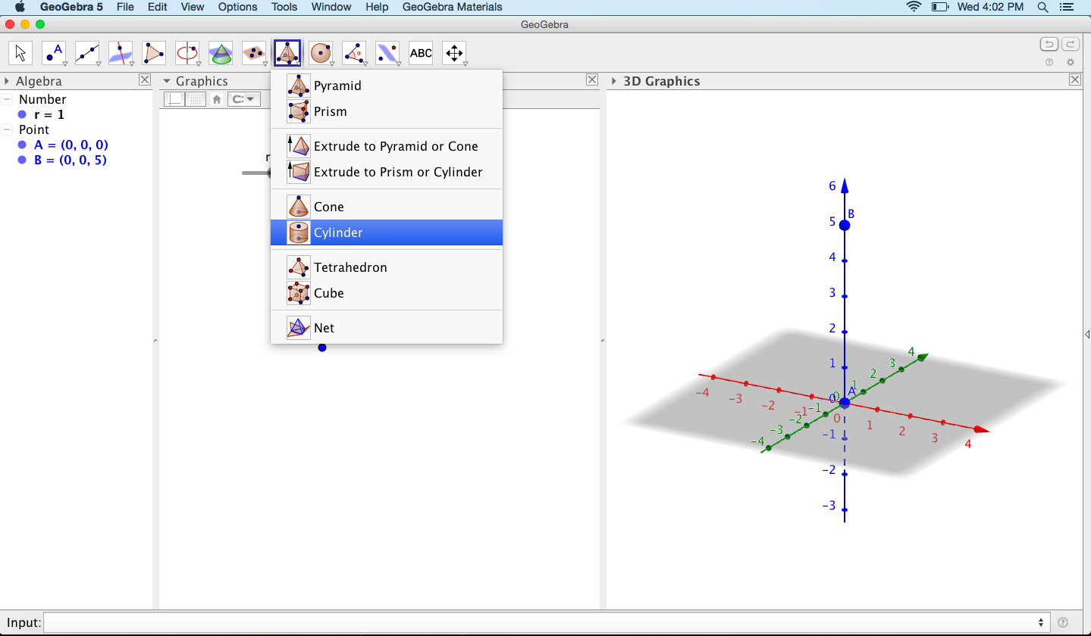  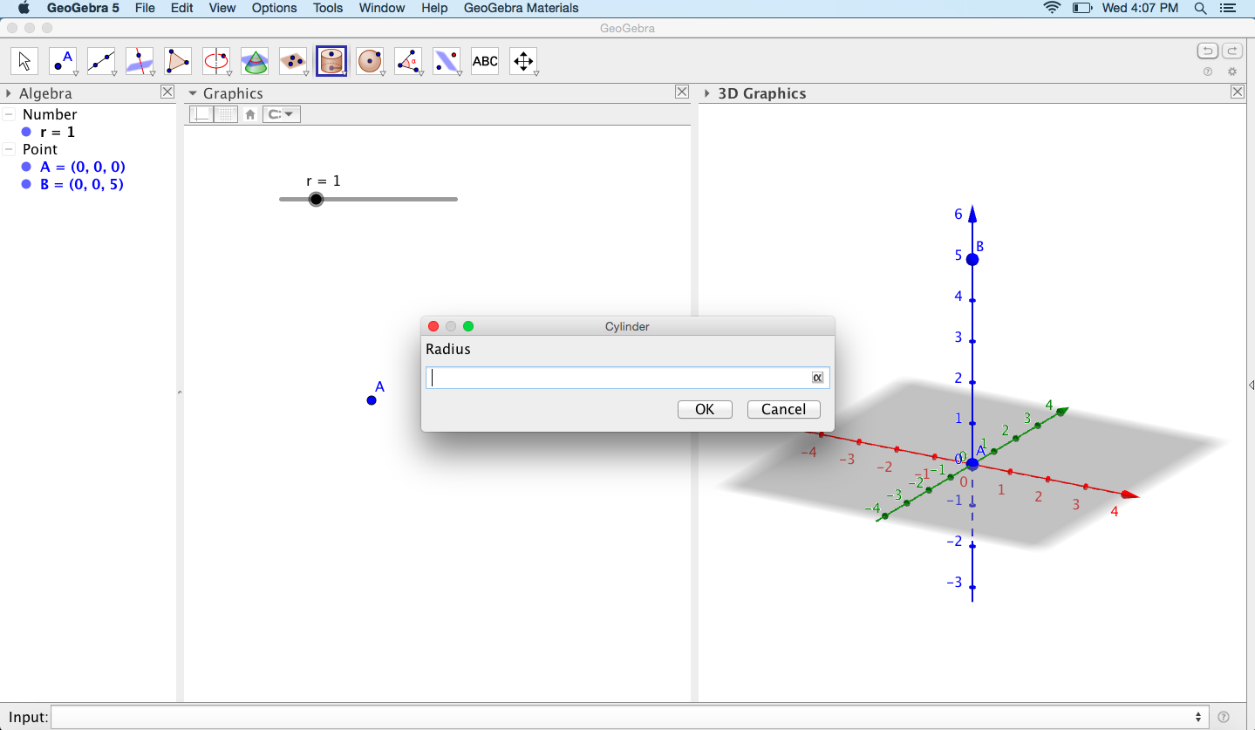
Step 7:  Insert a new slider: First click inside the white space under Graphic. On the top menu, select the second to last graphic a=2. (If you hover over this graphic with your mouse it will say Slider.)  After you have selected the Slider option from the top menu, click inside the white space under Graphic. When you do this, a menu will pop up on your screen. In the menu, change the name to h (h is for height) and change the Min to 0. In the increment section type 1. Then press Ok. | 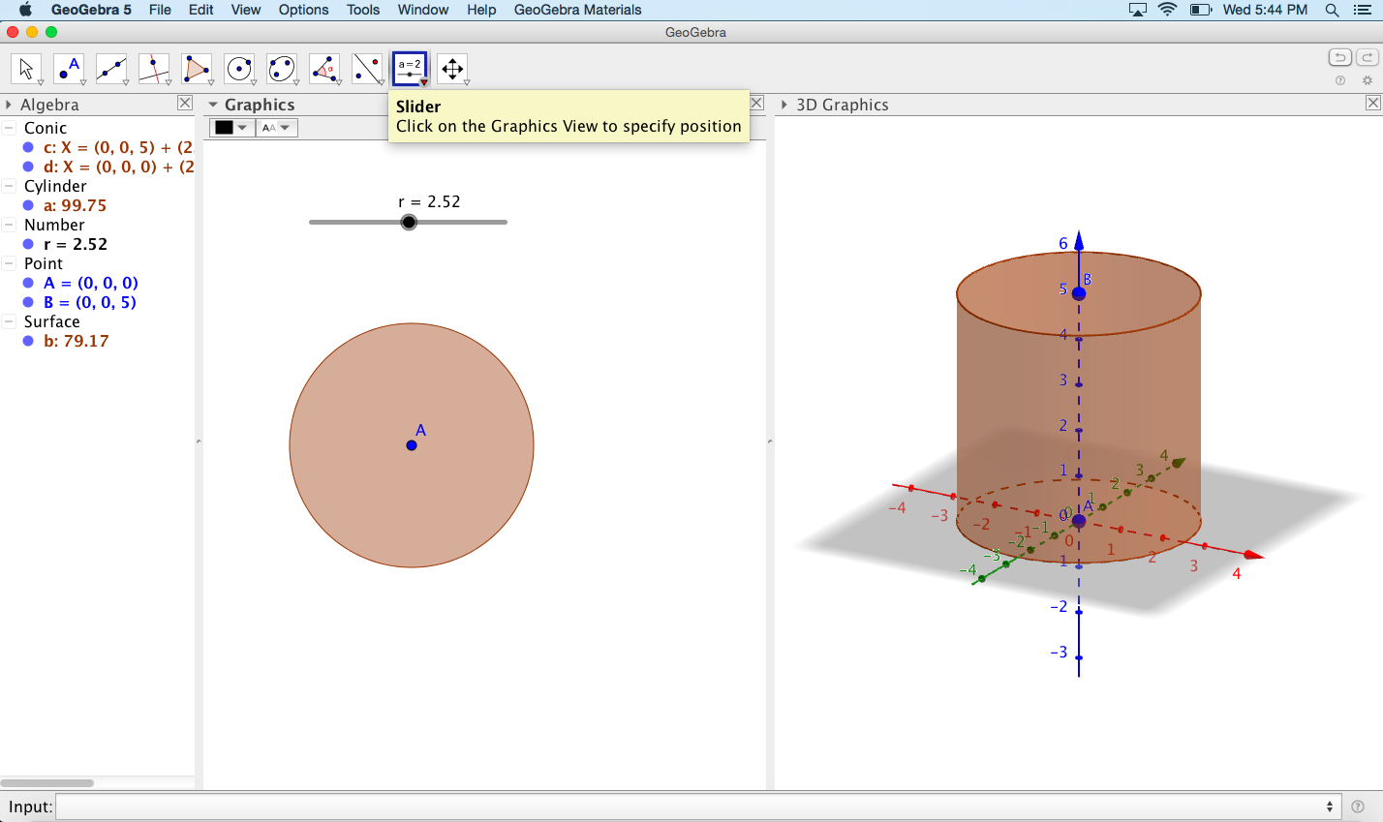  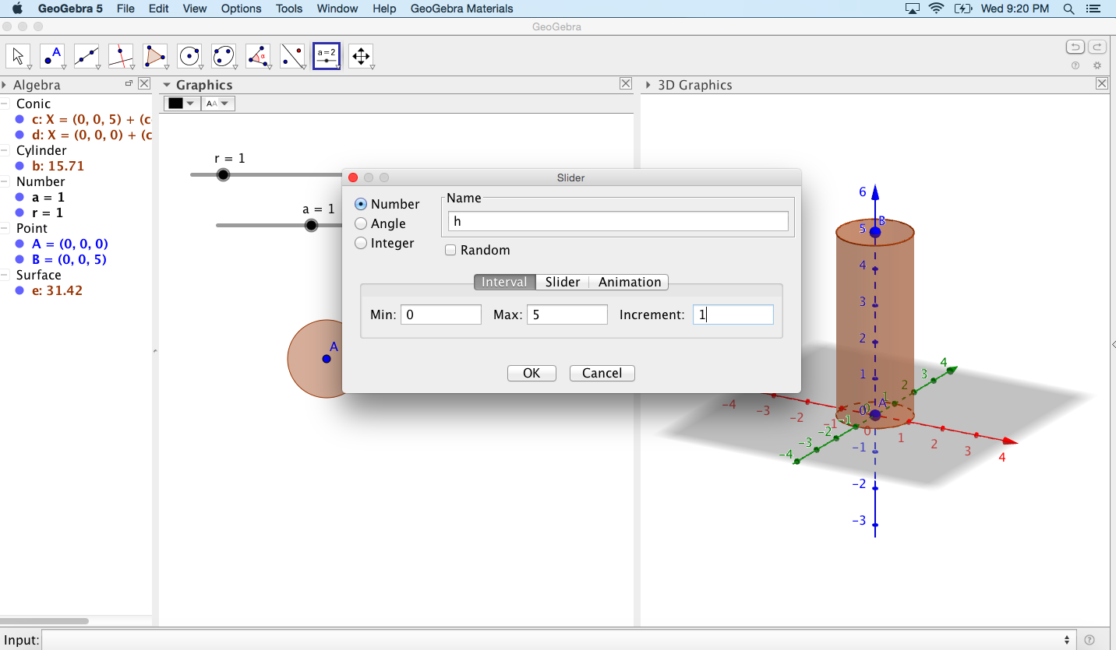
Step 8:  Plot Point C: Click inside the input tab on the bottom of your screen. Type C=(0,0,h) into your input and press ENTER | 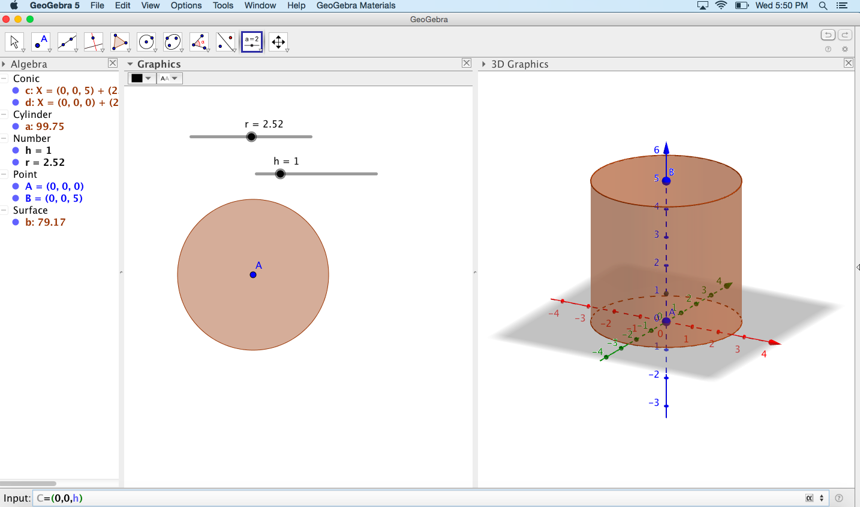
Step 9:  Hide the Axes: First click inside the 3D Graphics graph. If a box for a new slider pops up, click cancel. Select the Move Arrow on the top left of the screen. Then click the triangle next to the word 3D Graphics and select the first option on the dropdown menu. (If you keep your mouse hovered over this option it should say Show or hide the axes)  Hide the xOy plane: Click on the third icon to hide the xOy plane | 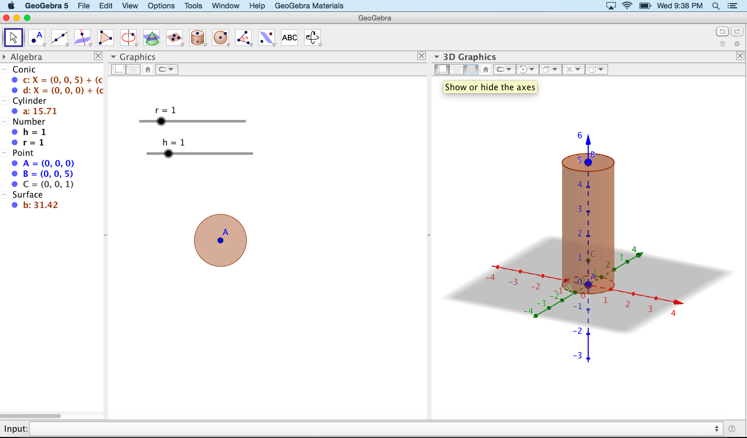  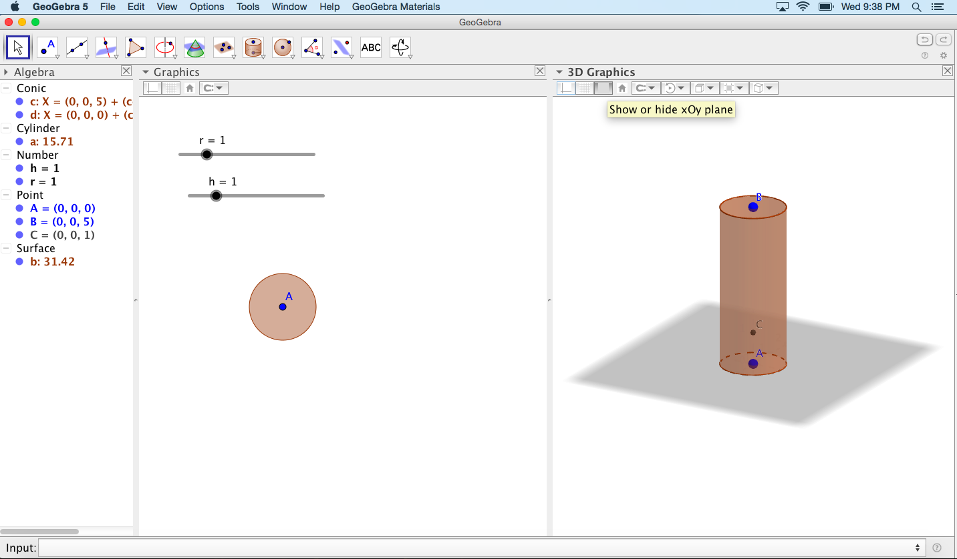
Step 10:  Show Object: On the left side of your screen click on Point then press control and right click then select Show object | 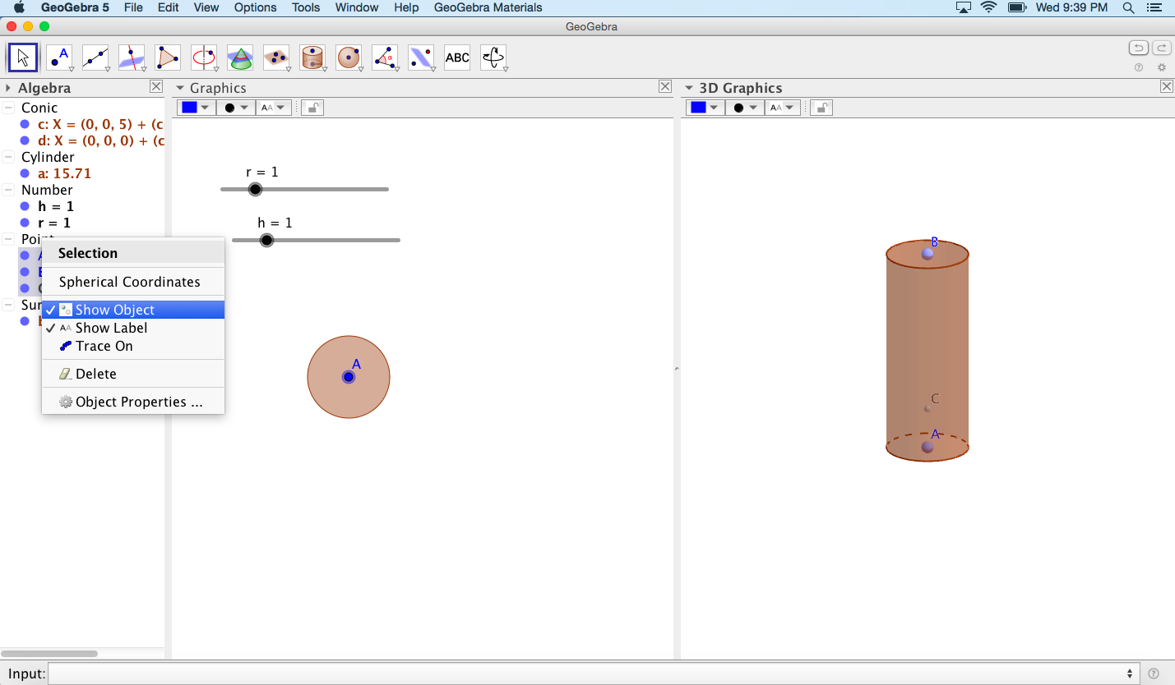
Step 11:  Plot Volume: Click inside the input tab on the bottom of your screen. Type V=r^2*Pi*h and press ENTER | 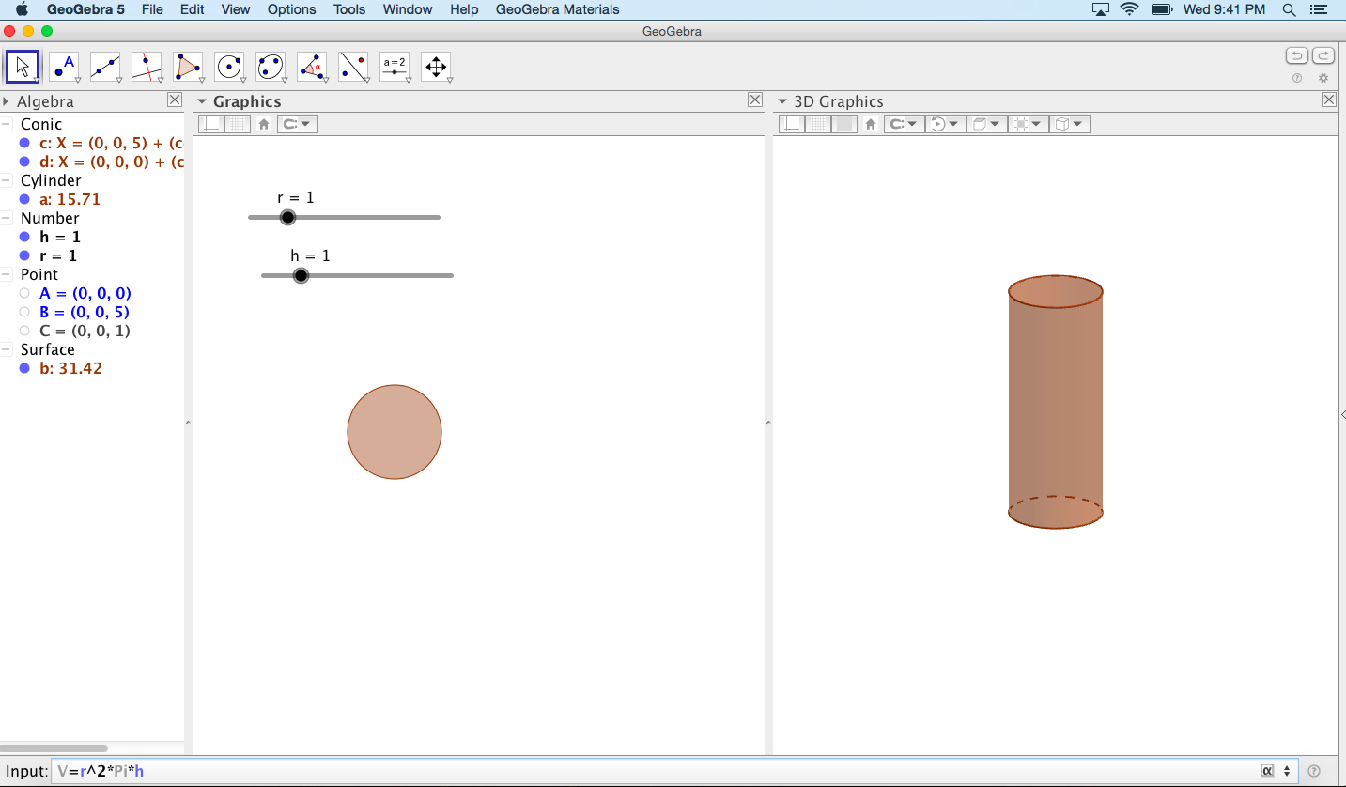
Step 12: First click inside the white space under3D Graphics. Then select the thirteenth icon that says ABC. Once you’ve selected this icon, click inside the white space under3D Graphics. A pop up menu will appear. Inside the popup menu, type into the Edit section. Type V=, then press the V= on the left side bar. Then check the box that says LaTeX formula. Press Ok. | 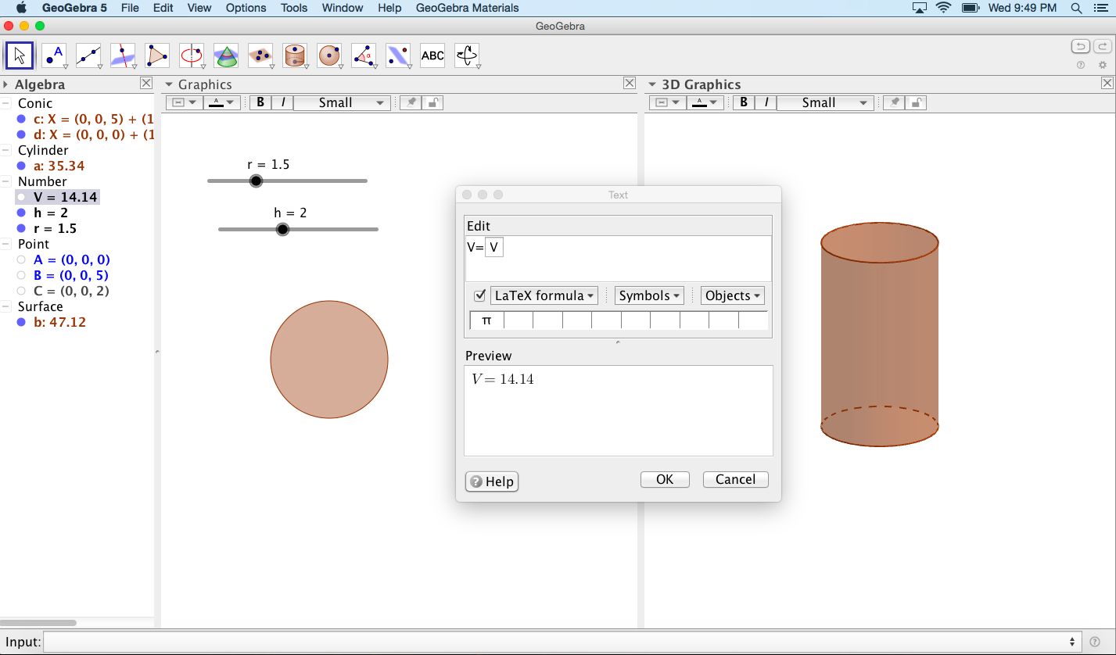

Practice Problems:
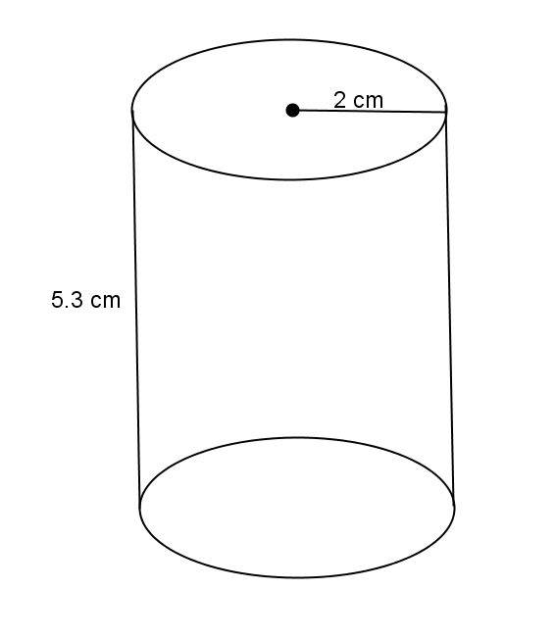
- Use the diagram to the right to answer the questions.
  - What is the area of the base?

  - What is the height?

  - What is the volume of the right circular cylinder?

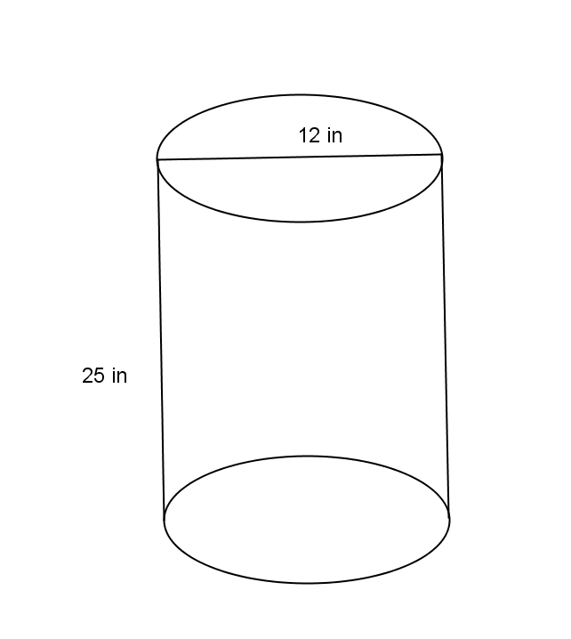
- Use the diagram to the right to answer the questions.
  - What is the area of the base?

  - What is the height?

  - What is the volume of the right circular cylinder?

- Use the diagram to help you find the volume of the right circular cylinder.
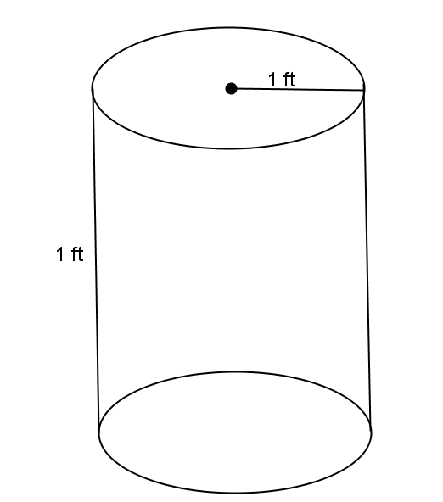

- Use the diagram to help you find the volume of the right circular cylinder.
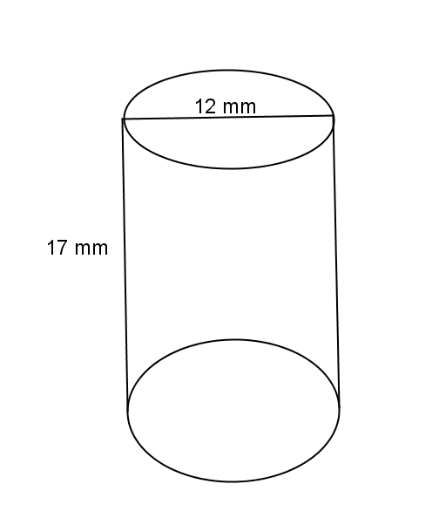

- A cylindrical tank (with dimensions shown below) contains water that is $1$-foot deep. If water is poured into the tank at a constant rate of $20 \frac{{ft}^{3}}{min}$ for $20 min$., will the tank overflow? Use $3.14$ to estimate $π.$

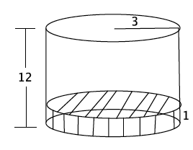

References
Cylinder. (2017). Retrieved March 8, 2017, from https://www.mathsisfun.com/geometry/cylinder.html#Volume
EngageNY. (n.d.). Retrieved March 8, 2017, from https://www.engageny.org/resource/grade-8-mathematics-module-5-topic-b-lesson-10/file/48441
GeoGebra. (2017). Retrieved March 8, 2017, from https://www.geogebra.org/home
Habecker, D. (2012, August 08). Volume of cylinder. Retrieved March 8, 2017, from https://www.geogebra.org/m/GSBWZBYT
Matematike, S. (Director). (2016, June 14). Volume of a cylinder (animated) in geogebra [tutorial] [Video file]. Retrieved March 8, 2017, from https://www.youtube.com/watch?v=wEKAGGB4Mng
New york state p-12 common core learning standards for mathematics. (n.d.). Retrieved March 8, 2017, from https://www.engageny.org/resource/new-york-state-p-12-common-core-learning-standards-for-mathematics/file/741

