Volume of a Cylinder
Common Core Learning Standard
CCSS.MATH.CONTENT.8.G.C.9
Know the formulas for the volumes of cones, cylinders, and spheres and use them to solve real-world and mathematical problems.

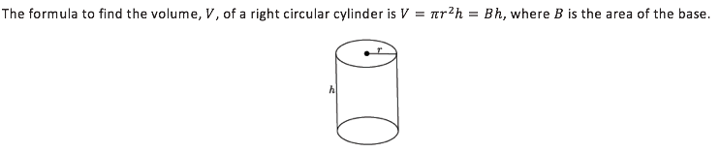
Volume of a cylinder= $π∙r^{2}∙h$

To find volume, we multiply the area of the base by the height of the cylinder

Area of the base = $π∙r^{2}$

Height = $h$

Volume = Area $∙$ Height = $π∙r^{2}∙h$

Example of Volume of a Cylinder:
h= 7 and r= 2
Volume = $π∙r^{2}∙h$
=$π∙2^{2}∙7$
= 28$π$
$≅$87.96
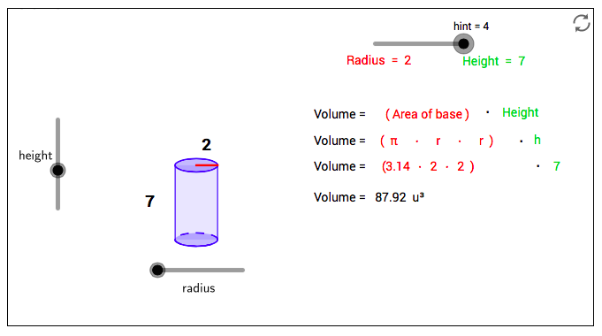
Step 1. Open up GeoGebra
Step 2: Select 3D Grapher under GeoGebra Math Apps | 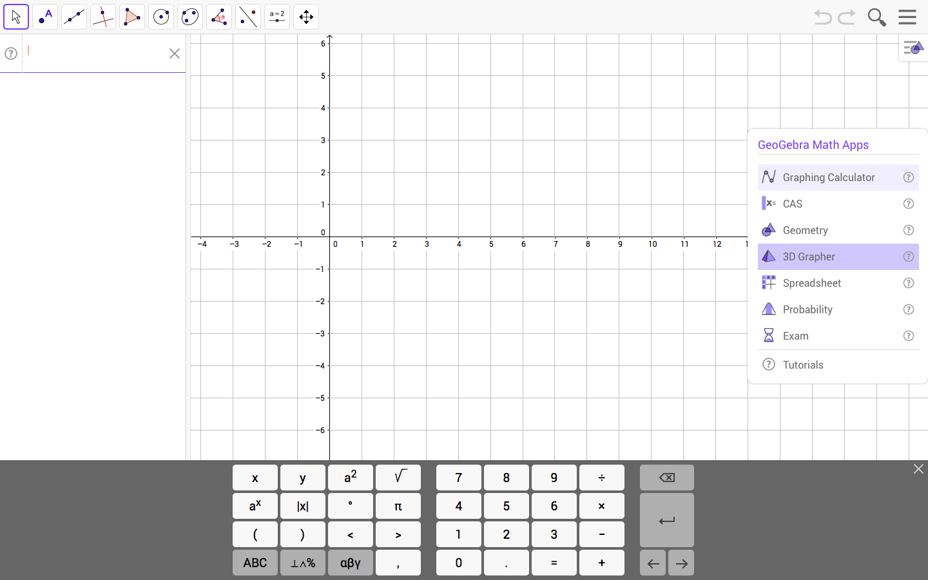
Step 3:  Plot Point A: Click inside the input tab on the left-hand side of your screen. Type  A= (0,0,0) into your input and press ENTER | 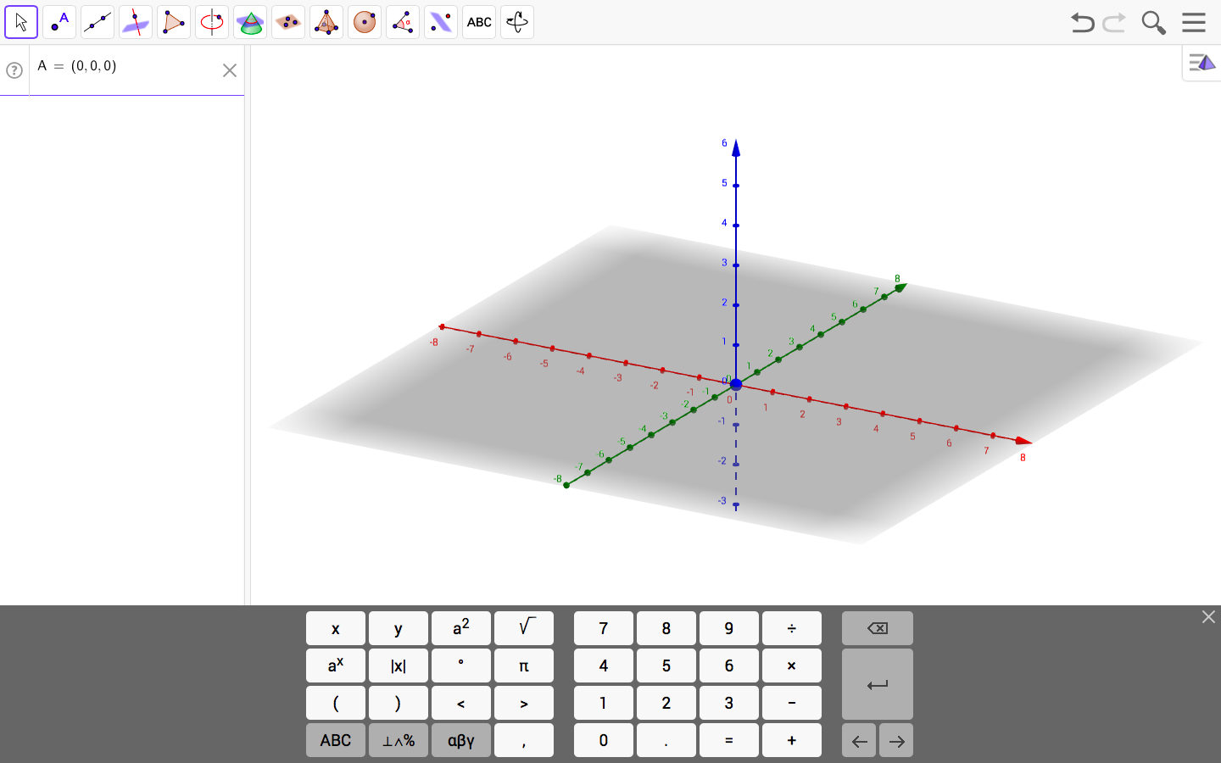
Step 4:  Plot Point B: Click inside the input tab on the left-hand side of your screen. Type  B= (0,0, h) into your input and press ENTER  Once you Press Enter, a pop up box labeled Create Sliders will appear on your screen. Click the bottom that says Create Sliders. | 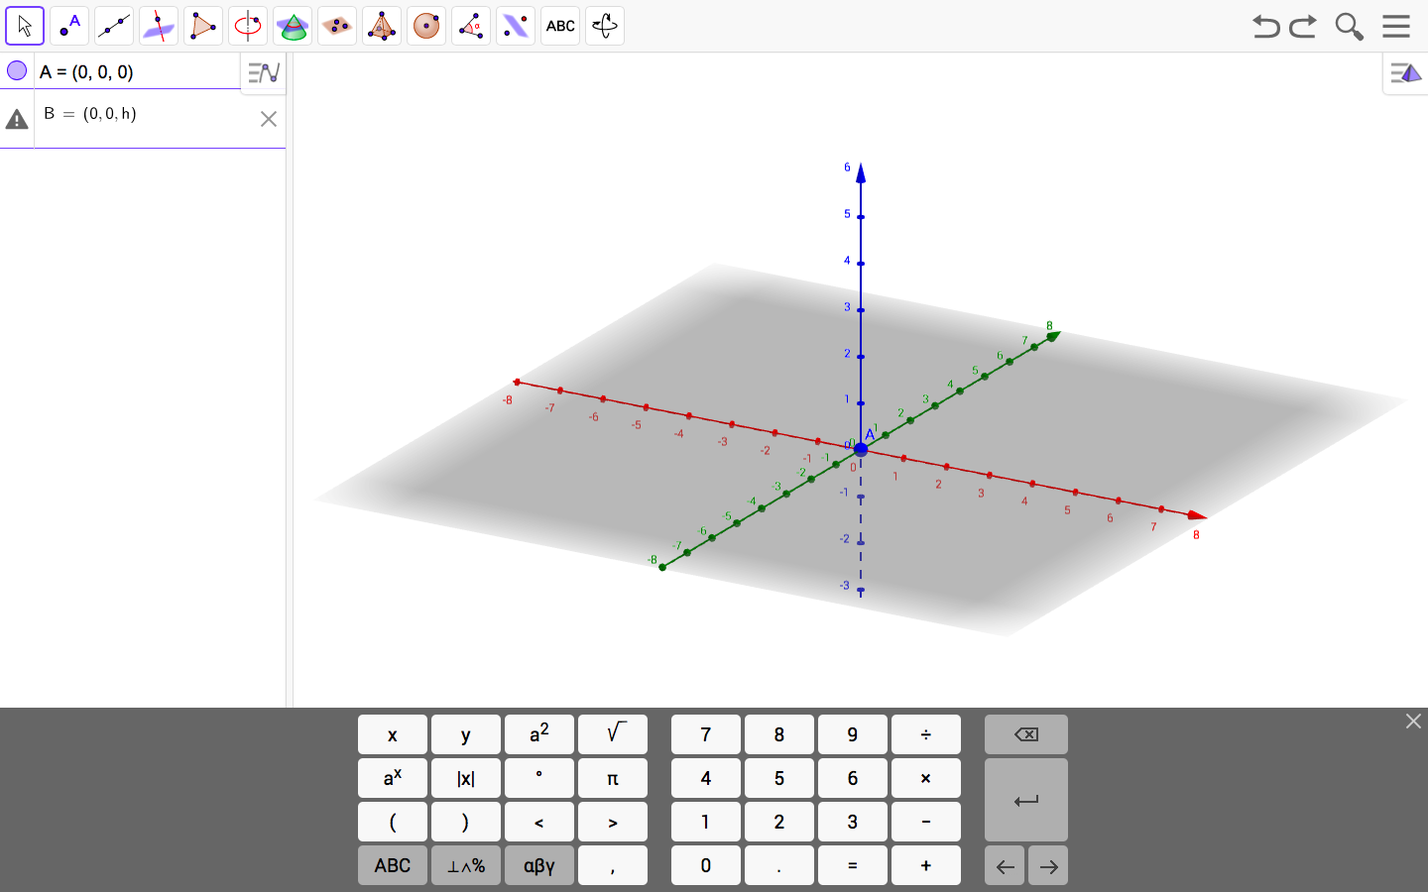  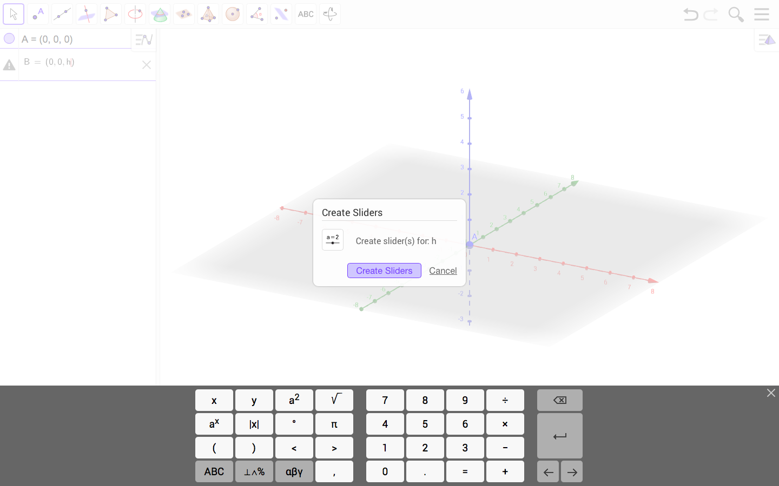
Step 5:  Insert a Cylinder: On the top menu click on the ninth graphic that looks like a pyramid. A drop-down menu will appear. Select the option cylinder on the dropdown menu.  Then, click on Point B, followed by Point A.  A pop-up box will appear on your screen. Inside the pop-up box type in r then press Ok.  When you do this, a different pop up box labeled Create Sliders will appear on your screen. Click the bottom that says Create Sliders. | 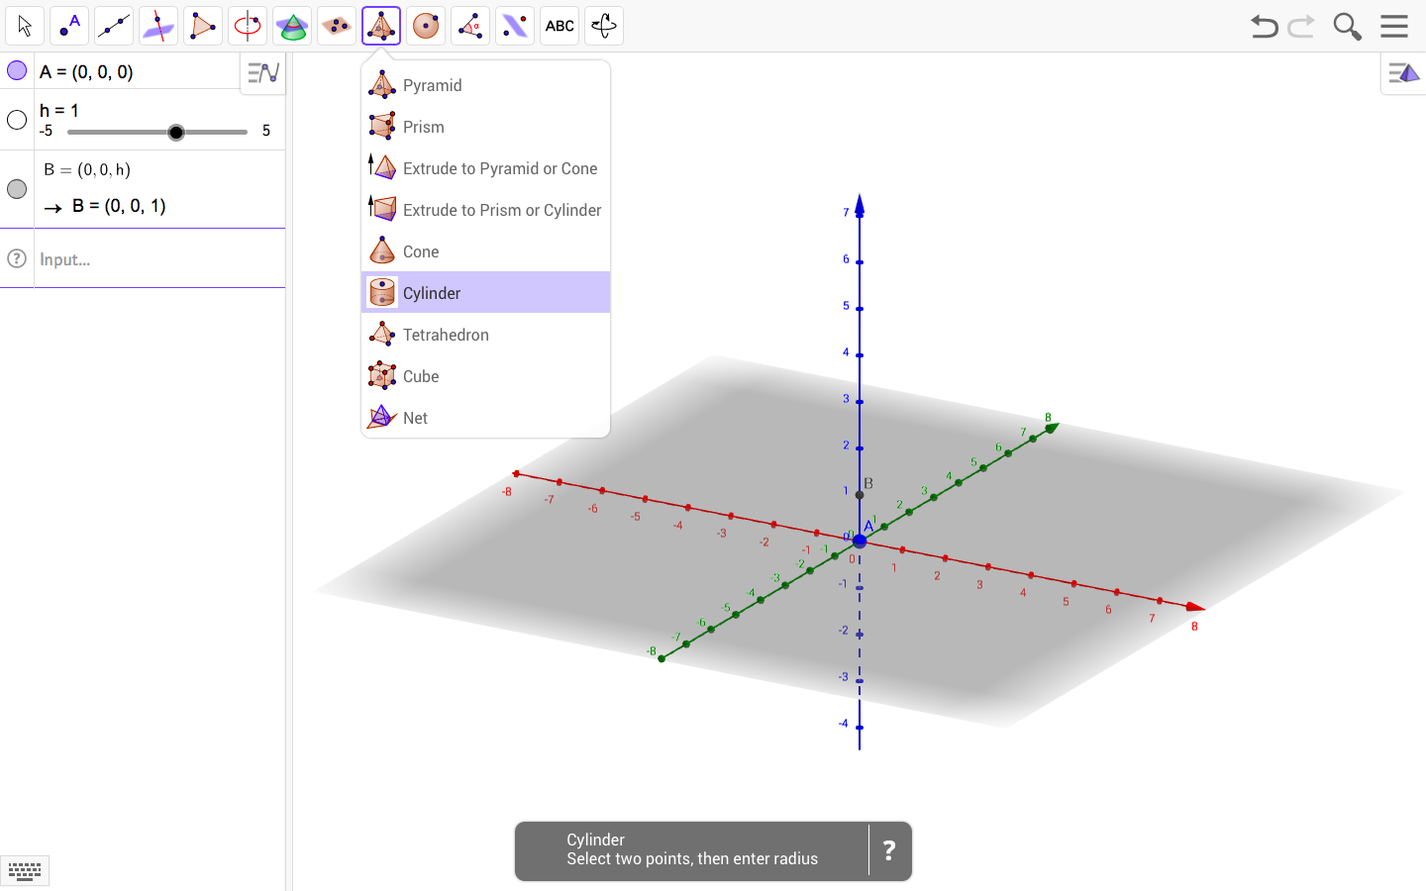  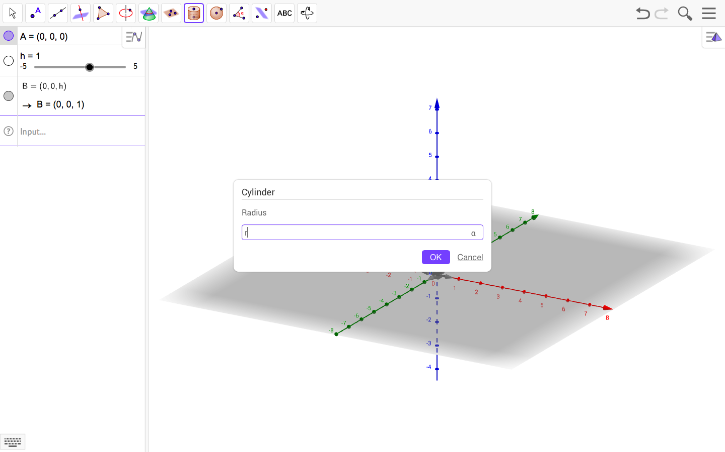  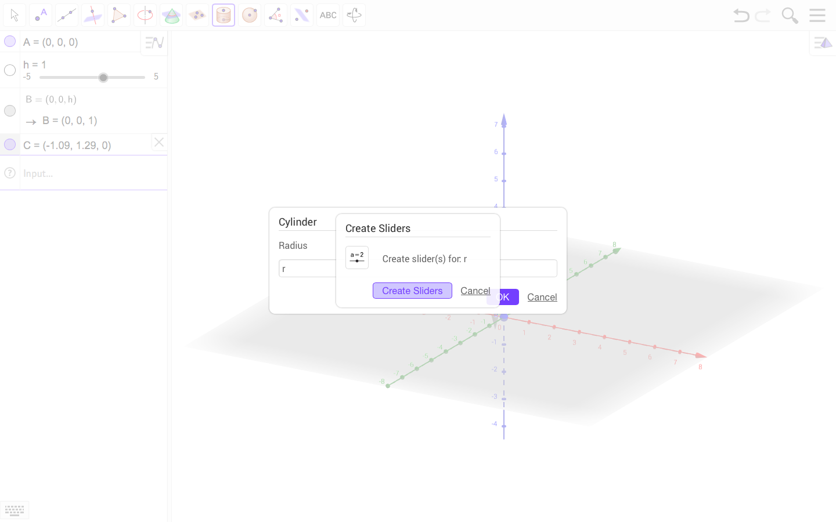
Step 6:  Select the move icon on the top left of your screen. (It looks like an arrow).  Then, Hide the Axes and xOy Plane. You can do this by first selecting the pyramid icon on the far-right side of your screen. When you click on this icon, it will open a larger menu containing seven different icons. Select the first icon, furthest to the left. A drop-down menu will appear. When this occurs select the blank icon (the first icon on the left).  Hide Points A and B. You can do this by clicking on the circles that correspond with each of these Points within the input tab on the left-hand side of your screen. | 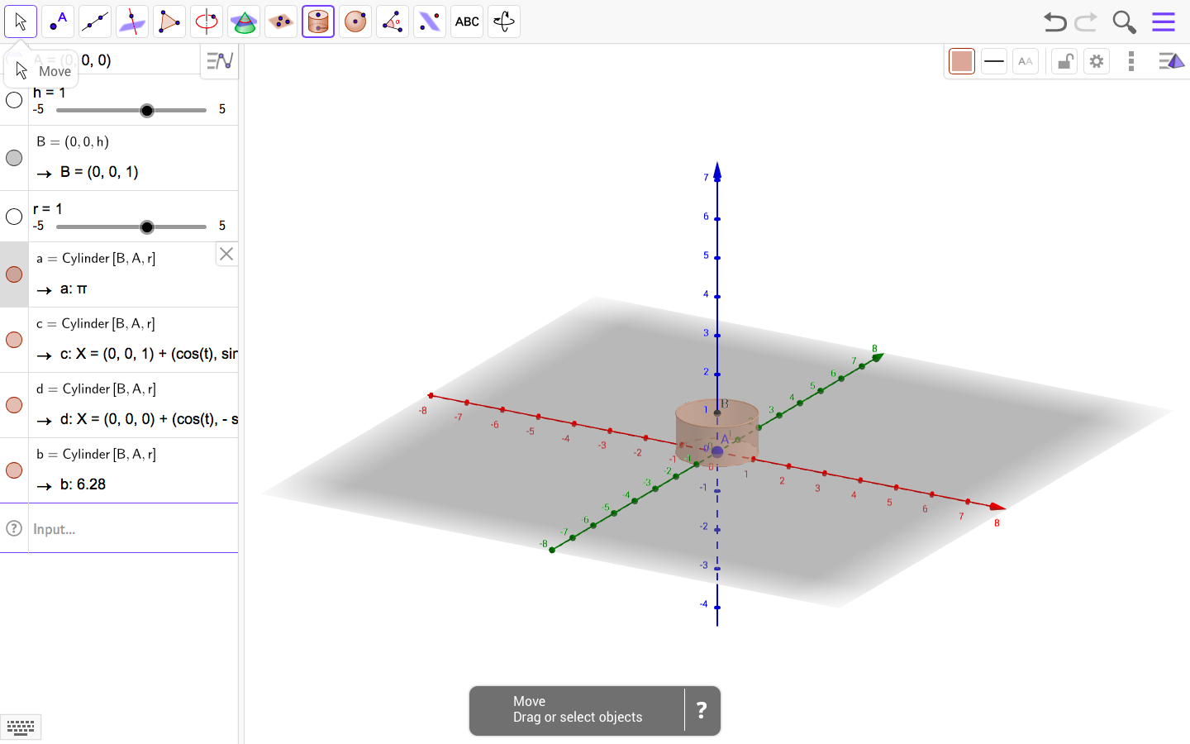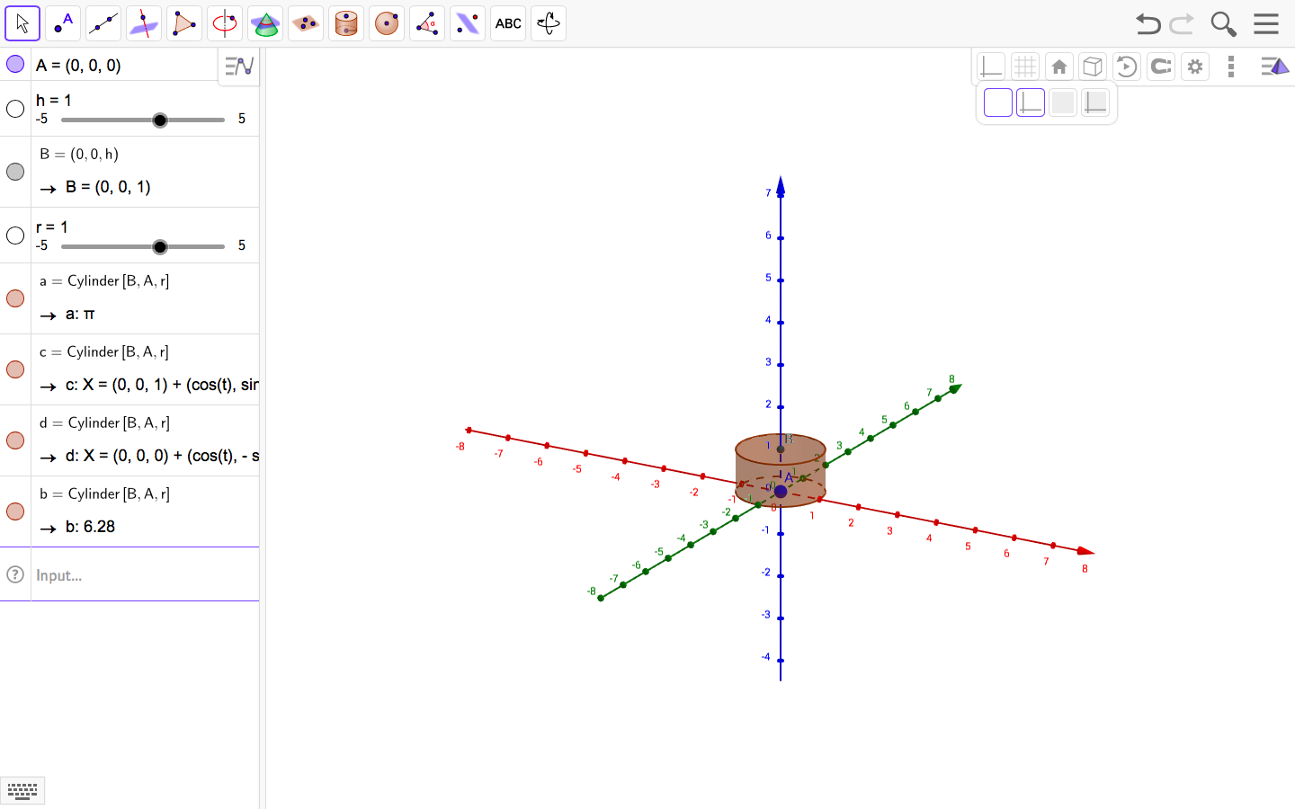  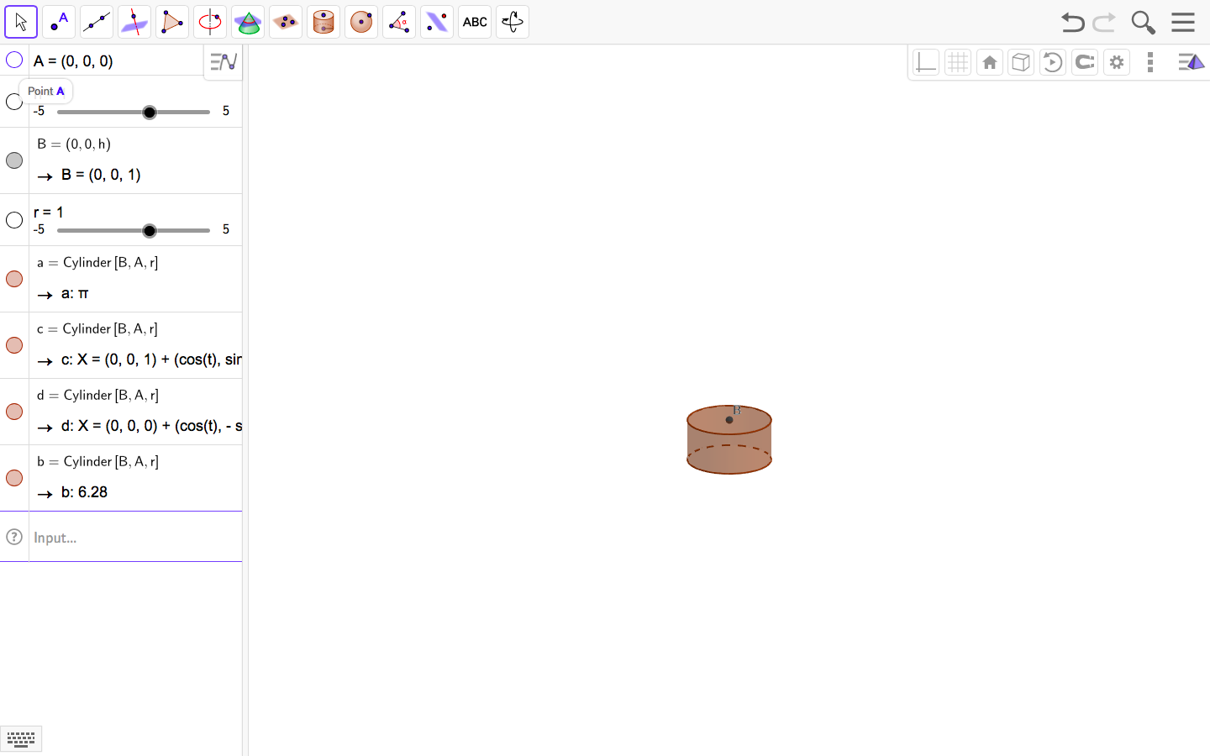
Step 7: Click inside the input tab on the left-hand side of your screen. Type V = $π*r^{2}*h$  into the input tab and press ENTER | 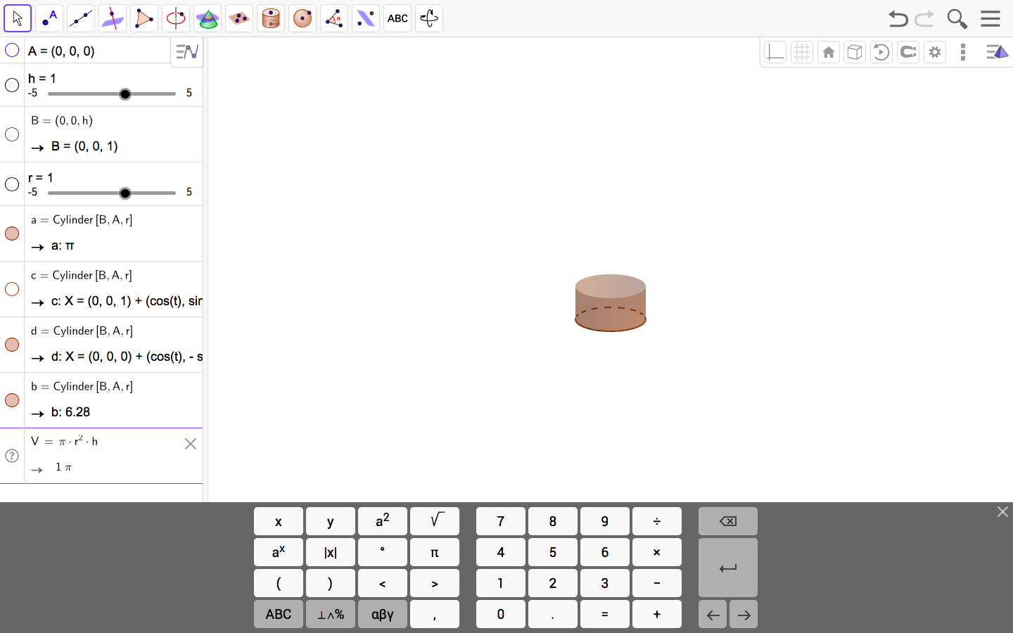
Step 8:  Play around with the height and radius sliders within your input tab. As you move the height and radius sliders, you will notice that the volume changes.  You can see the volume written as a decimal or in terms of Pi by clicking on the blue square next to your volume formula in your input tab. | 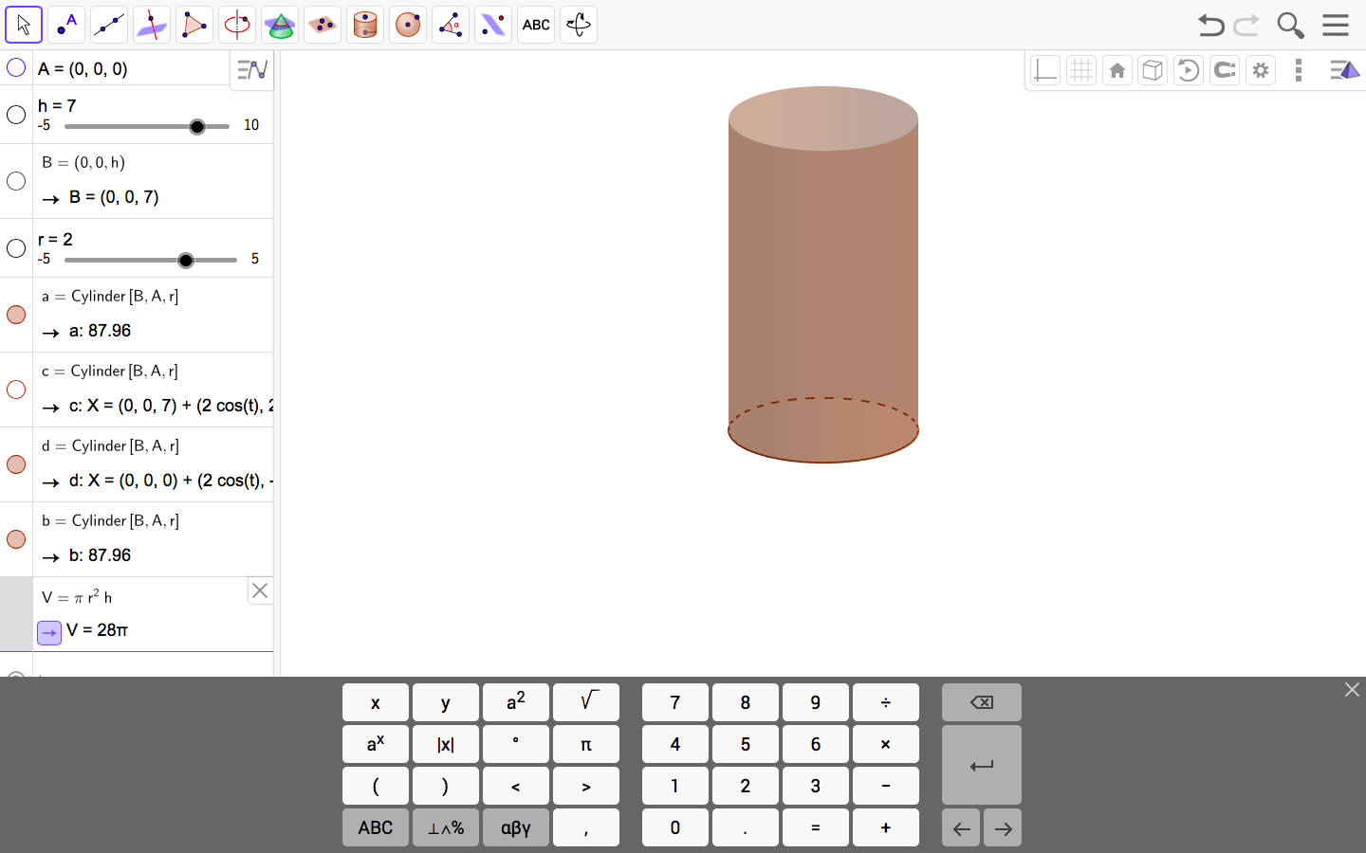  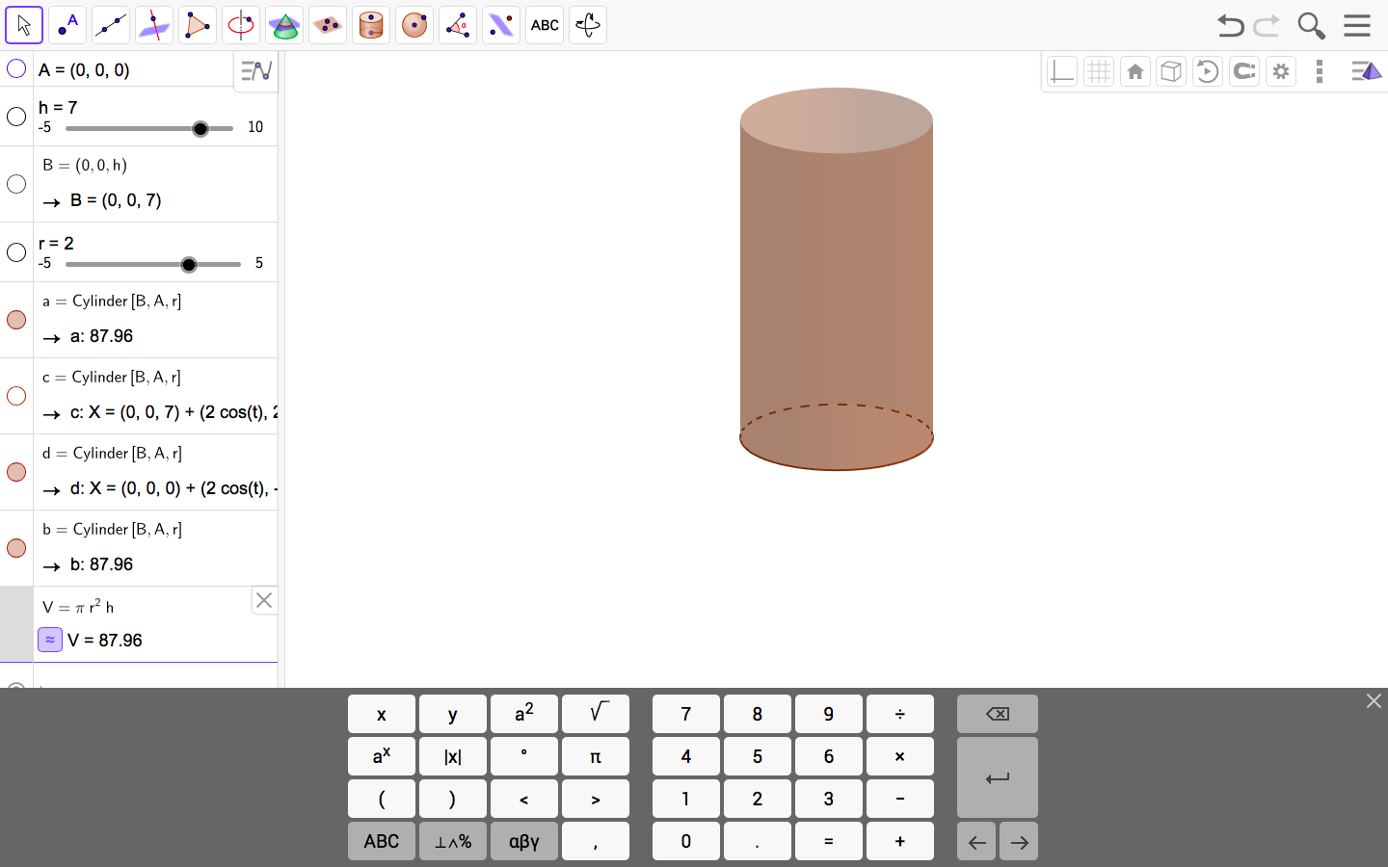

Practice Problems:
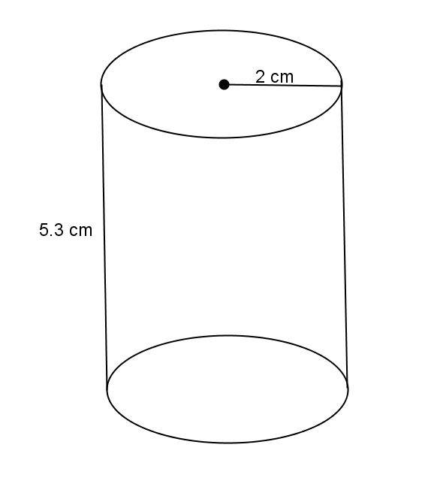
- Use the diagram to the right to answer the questions.
  - What is the area of the base?

  - What is the height?

  - What is the volume of the right circular cylinder?

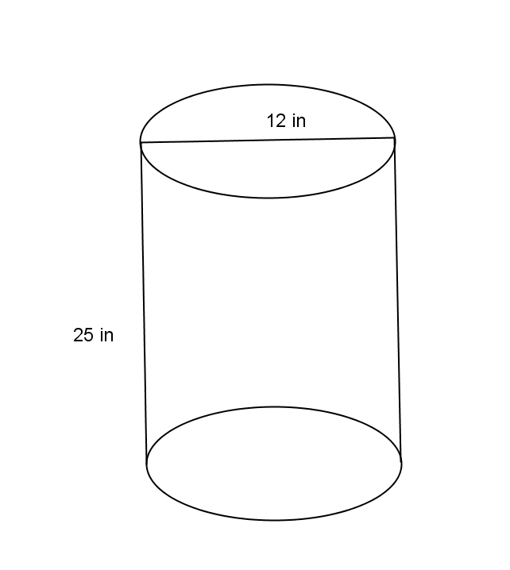
- Use the diagram to the right to answer the questions.
  - What is the area of the base?

  - What is the height?

  - What is the volume of the right circular cylinder?

- Use the diagram to help you find the volume of the right circular cylinder.
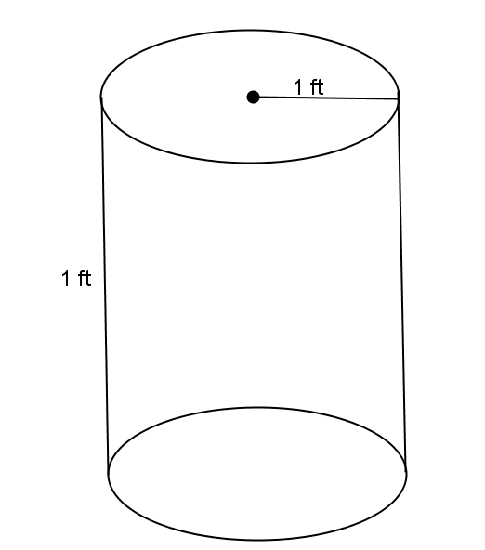

- Use the diagram to help you find the volume of the right circular cylinder.
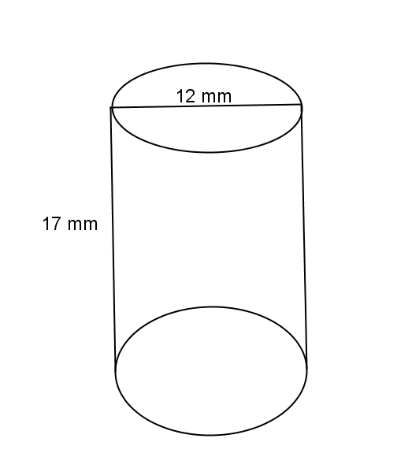

- A cylindrical tank (with dimensions shown below) contains water that is $1$-foot deep. If water is poured into the tank at a constant rate of $20 \frac{{ft}^{3}}{min}$ for $20 min$., will the tank overflow? Use $3.14$ to estimate $π.$

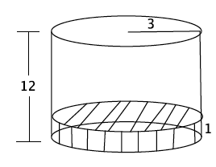

References
Cylinder. (2017). Retrieved March 8, 2017, from https://www.mathsisfun.com/geometry/cylinder.html#Volume
EngageNY. (n.d.). Retrieved March 8, 2017, from https://www.engageny.org/resource/grade-8-mathematics-module-5-topic-b-lesson-10/file/48441
GeoGebra. (2017). Retrieved March 8, 2017, from https://www.geogebra.org/home
Habecker, D. (2012, August 08). Volume of cylinder. Retrieved March 8, 2017, from https://www.geogebra.org/m/GSBWZBYT
Matematike, S. (Director). (2016, June 14). Volume of a cylinder (animated) in geogebra [tutorial] [Video file]. Retrieved March 8, 2017, from https://www.youtube.com/watch?v=wEKAGGB4Mng
New york state p-12 common core learning standards for mathematics. (n.d.). Retrieved March 8, 2017, from https://www.engageny.org/resource/new-york-state-p-12-common-core-learning-standards-for-mathematics/file/741

