Heather Nolan
Hands-On Activity
Grade Level: 8th Grade

How many cones does it take?
Goal:
Students will investigate and compare the volumes of cylinders and cones with matching radius and height. Students will discover that a cone's volume is one-third a cylinder's volume when the corresponding radius and height are equal.

Objective:
Given a hands-on activity comparing the volume of cylinders and cones with matching radius and height, students will complete a volume of cones and cylinders exit ticket with 80% accuracy.

Standards:
New York State P-12 Common Core Learning Standards for Mathematics
Solve real-world and mathematical problems involving volume of cylinders, cones, and spheres.
CCSS.MATH.CONTENT.8.G.C.9
Know the formulas for the volumes of cones, cylinders, and spheres and use them to solve real-world and mathematical problems.

Materials:
- Card stock for the cones
- Cylinders of various shapes and sizes (cans, oatmeal containers, etc.)
- Pencils
- Rulers
- Tape
- Scissors
- Protractor
- Compass
- Filler (pom-pom, rice, sand, sugar, oatmeal, etc.)

Formulas:
Volume of a right circular cylinder
V = $π∙r^{2}∙h$ or V=Bh

Volume of a Right Circular Cone
V= $\frac{1}{3} π∙r^{2}∙h$ or V= $\frac{1}{3} Bh$

Vocabulary:
Volume: the amount of space that a substance or object occupies, or that is enclosed within a container

Do Now: I have a cylinder that has a height of 4 inches and a diameter of 2 ½ inches. I also have a cone with a height of 4 inches and a diameter of 2 ½ inches. If I fill my cone with pom-poms and pour them into my cylinder, how many times will I have to fill my cone with pom-poms before I fill up my cylinder?

Prediction: I predict that I will have to fill my cone __________ times with pom-poms before I can fill my cylinder.

Directions:
- The first thing we must do is measure our cylinder. When we measure our cylinder, we can see that it has a height of 4inches and a diameter of 2 ½ inches. This means that our cylinder has a radius of 1.25 inches | 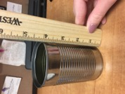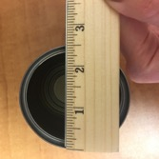
- Once we have measured our cylinder, the next thing we must do is create a cone that has the same radius and height as our cylinder.
- Constructing our cone is going to be a multi-step process which begins with calculations. The key to creating our cone is this fact every cone can be flattened into a sector of a circle. Therefore, to construct a cone with a height of 4 inches and a radius of 1.25 inches, we need to calculate two variables L and θ. L represents our slant height and is calculated using the formula  $$L=\sqrt{h^{2}+r^{2} }$$  This formula may look familiar to you, we are using the Pythagorean theorem  $$a^{2}+ b^{2}=c^{2}$$  to calculate our L.  θ represents the angle and is calculated using the formula  $$= 360 ∙\frac{r}{L}$$ | 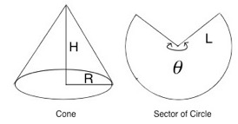
- Let’s try preforming these calculations using the information we gathered by measuring the height and radius of our cylinder | I want to construct a paper cone that is 4 inches tall and 2.5 inches across. Thus, H = 4 and R = 2.5/2 = 1.25.  Step 1: Calculate L  $$L=\sqrt{h^{2}+r^{2} }$$  $$L= \sqrt{4^{2}+{1.25}^{2} }$$  $$L= \sqrt{17.5625 }$$  $$L=4.190763654$$  $$L≈4$$  Step 2: Calculate the sector angle θ  $$= 360 ∙\frac{r}{L}$$  $$= 360 ∙ \frac{1.25}{4}$$  $$≈112.5$$
- Now that we have made these calculations, we can draw the conclusion that to construct a cone with the required dimensions, we must start with a circular sector that has a radius of 4 inches and an angle of 112.5 degrees. Using this size and shape yields a cone whose height is exactly 4 inches and diameter exactly 2 ½ inches.
- Time to start drawing our cone! You will need your cardstock, pencil, ruler, protractor, scissors, tape and compass. | 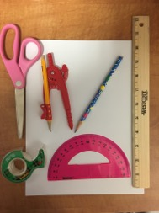
- Start by plotting a point in the center of your cardstock and label it P
- Set your compass to 4 inches. Then, place the point of your compass on your point P and begin drawing your circle. | 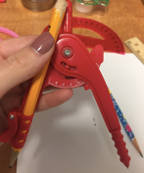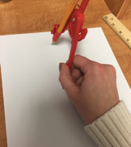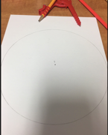
- Use your protractor to draw the angle 112.5 degrees, which we calculated earlier. | 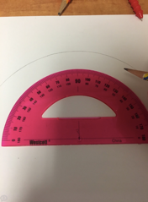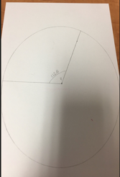
- Once you have drawn your angle, you can cut out the area of your circle created by that angle
- Use the piece of cardstock that you just cut out to create your cone. You can do this by folding the two ends together and tapping them in place. Now you have your cone! | 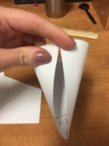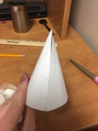
- Check to make sure that your cone is the correct height and radius using your ruler.  Another trick to make sure your cone is the correct size is to see if your cone fits snug inside your cylinder! | 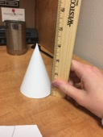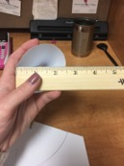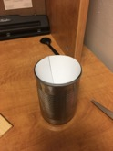
- Fill your cone with pom-poms and pour the pom-poms into your cylinder. You will notice that it did not fill the entire cylinder. | 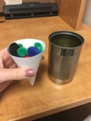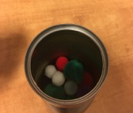
- Fill you cone for a second time with pom-poms and pour the pom-poms into your cylinder. You will notice that your cylinder is still not full. | 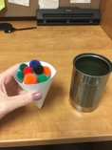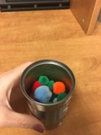
- Fill your cone with pom-poms for a third time and pour them into your cylinder. This time you will notice that the cylinder is full! | 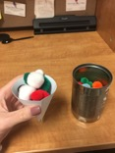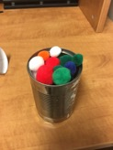

Was your prediction correct?

______ Yes ______No

Conclusion:
A cone's volume is one-third a cylinder's volume when the corresponding radius and height are equal.

Challenge:
Try this activity at home with different size cylinders. You will see that no matter what size cylinder you start with, you will always have to fill your cone 3 times with pom-poms before you can fill the cylinder.

Volume of Cones and Cylinders Exit Ticket:
- Using the formula for volume of a cylinder, calculate the volume of a cylinder with a diameter of 10 in. and a height of 7 in. What is the volume of a cone with the same dimensions?
- Using the formula for volume of a cone, calculate the volume of a cone that has a diameter of 12cm and a height of 22cm. What is the volume of a cylinder with the same dimensions?
- Using the formula for volume of a cylinder, calculate the height of a cylinder that has a diameter of 5cm and a volume of 55cm cubed. What is the volume of a cone with the same dimensions?
- How are the formulas for the volume of a cone and cylinder similar and different? Why are certain parts similar and why are certain parts different?
- Given the height of 10 ft. and a diameter of 3 ft., what is the volume of a cone and cylinder with these dimensions?
- If the volume of a cone is 82 in. cubed and the diameter is 7 in., what is the height? What is the cylinder's volume with the same height and diameter?
- How is the volume of a cylinder related to the volume of a cone?
References:
EngageNY. (n.d.). Retrieved March 8, 2017, from https://www.engageny.org/resource/grade-8-mathematics-module-5-topic-b-lesson-10/file/48441
Jones, B. (n.d.). How many cones does it take? Retrieved April 26, 2017, from http://www.cpalms.org/Public/PreviewResourceLesson/Preview/43531
S. (2016, May 12). Modular Cones for Crafts and More. Retrieved April 26, 2017, from http://www.instructables.com/id/Modular-Cones-for-Crafts-and-More/

